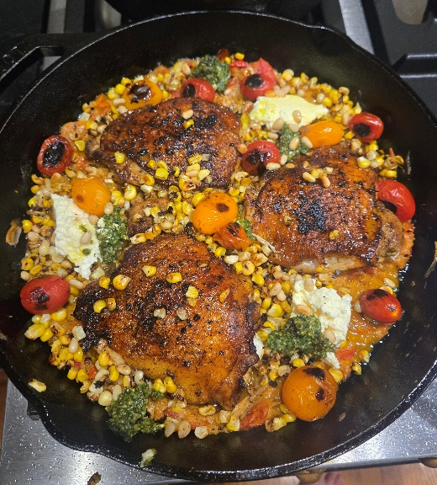
California Abundance: Cast Iron Pan Chicken
The list of grievances of living in California are well known: high cost of living, thick traffic, cheaply built housing, excessive taxes, high gas prices, onerous regulation, etc. I am often asked, why in gods’ names do I live there? When paying my mortgage, I have stopped to contemplate this question. And then spring arrives, and with it, the bounty of California fruit and vegetables. Grocery shopping, whether at a store or farmers market, becomes a body-tingling experience. This feeling hits a crescendo come mid-summer when all the peaches and stone fruits are bursting in sweet, tangy exuberance and the squash, corn, beans, tomatoes, sprouts, onions, eggplants, mushrooms, and on and on stack up in colorful piles. It is just a cornucopia of goodness. My shopping cart groans with “must-haves” and “holy wow, look at that” sourced from farms with cute names and stories. The long-time Cali residents may become a little inured to our good fortune until an outsider comes to visit (my out-of-towner was my Costa Rican friend, John). John just about plotzed when he saw the table laid for a midweek dinner including grilled peaches, pan fried corn, seared squash, blackened Jimmy Nardello peppers and rocket onions, alongside salmon caught off the coast of Pt. Arena. We weren't in Playa Grande any longer, Toto.
My wife Ami threw this dish together a few years ago and it has become a summer staple. It is easy, quick, and delicious. There is a lot of room for creativity, so use this as a guide and add in whatever is looking best at the market that day (the photo above has at the base smoked/blackened Japanese eggplant innards used for this dish before the remainder went into baba ganoush). This dish will go great with both our Chardonnay and our Pinot Noir as the juicy fresh acidity in our wines marry well with the tangy acidity of the cherry tomatoes and the green flavors of pesto and creamy ricotta in a bite of seared chicken thigh. A match made in heaven (or a place named California).

Chicken Ingredients:
4 Chicken thighs—organic, free range
Curry powder—I like vadouvan
Thyme (optional)
Butter
Seed oil—to cook high heat
3 ears corn
20-25 cherry tomatoes
3 garlic cloves—diced
Ricotta cheese (or chevre or feta)
Olive oil—to dress

Brine Ingredients:
1 gallon warm water, or enough to cover
1 cup of salt
1/2 cup sugar (optional)
Few sprigs fresh thyme (optional)
Bunch of peppercorns (optional)
Bay Leaf (optional)

Pesto Ingredients:
1 bunch Basil—3 to 4 cups
4 garlic cloves
3/4 cup grated Parmesan cheese
1/4 cup pine nuts (toasted)
1/2 cup olive oil
Squeeze of a lemon (to taste)

To Prepare:
· Brine: Mix together brining ingredients, stir to dissolve salt and sugar (if using). Insert meat, be sure fully submerged. Leave on counter, no need to refrigerate. If you don’t brine your chicken, pork et al. let me just say it makes a HUGE difference in the juiciness and texture of the cooked meat. Worth it. I personally don’t sweat “over-brining” so go ahead and drop the meat in the brine and go to work and fish it out afterwards. Yes, that is 2-3 times the length recommended by most chefs but don’t add excessive salt when cooking and likely it will be a-okay.
· Pesto: Mix all ingredients in a food processor or blender and blend until creamy and smooth.
· Chicken: Rinse chicken breasts and pat dry with a paper towel. Roll thighs in the curry powder and thyme (optional) dry rub and let them sit as long as you can in fridge until it is time to cook (minutes to overnight).
· Shuck corn and cut the kernels off the ear and collect in a bowl. Chop garlic.
· Heat your cast iron pan on high heat. Add some seed or olive oil to the pan. Place chicken thighs skin down in pan and sear the skin until crispy brown (stop before blackening, see photo). A bacon or meat press is a very effective way to improve the sear. Add some butter to assist in the browning but careful, it burns and smokes. Flip thighs meat side down, lower flame, and cook for 5-10 minutes depending on size of thigh. Wanna have fun, add a few hunks of butter to pan, tilt pan, and spoon the butter over the thigh basting the meat. Yum. When cooked, remove chicken to a plate to rest while you prep the rest.
· If necessary, reheat your cast iron pan on high heat. If necessary, add seed oil to pan and cover bottom. When sizzling hot, add the corn kernels and the cherry tomatoes. Don’t stir often as you want them to blacken on the pan side. Scrape across pan with a wooden spoon when you see it getting crispy and tomatoes are bursting. Lower heat, add some chopped garlic, stir. Add chicken thighs as in photo. Add dollops of ricotta and pesto to the pan and submerge a little so they warm up and absorb some juices.
· Serve: Drizzle good olive oil over the dish. Serve in the pan for visual effect or plate.

